Visual Poetry, Spoken Word and Art
For this week’s art project students will be creating art based off of a poem. Read the included poems and select one from here or one from your own exploration. Next look at the examples of art and poetry included. Create your own work of art inspired by or in response to your selected poem. Include a selection of poem into your art. Take advantage of the many art opportunities (drawing, painting, collage, digital art, photography, video etc.). Make sure to include which poem you used when turning in through email your art piece. Lastly upload a photo of work and email it to instructions.
Steps for Project:
- Read all instructions and poems
- Review all art examples images
- Select one of the poems included
- Pick a portion or some lines of poem and include it in your art
- Choose your colors, images, design, feeling and subject in response to poem
- Create a work of art in response to poem
- Take Photo of work or digital file and email to instructor by 9/10/21
Extended work (not required)
- Create a work of art inspired by a poem you have written
- Research different Artist who use poetry in their Art
- Explore the illustrations and book of poems by Shel Silverstein
- Create a work of Art based off of a song
Knowledge and Standards
- Different media presentations of the same story can affect the way we experience it (tone, meaning, etc)
- Poetry can bring awareness to an issue that seems outside of ourselves
- (ELA 9.4.7.7) Analyze the representation of a subject or a key scene in two different artistic mediums, including what is emphasized or absent in each treatment
- (Visual Arts 9.1.2.2.1 1) Integrate tools, materials, and techniques to create original products for artistic purposes.
Poems and Art Image Examples
- “If I can stop one heart from breaking” by Emily Dickinson
If I can stop one heart from breaking, I shall not live in vain; If I can ease one life the aching, Or cool one pain, Or fainting robin Unto his nest again, I shall not live in vain.

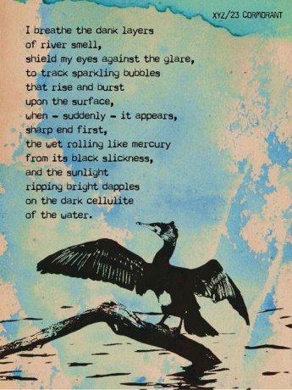
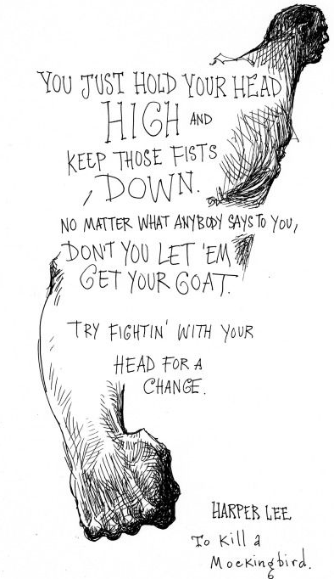
- “Please Resist Me” by Luka Lesson Please resist me Colonise me, compromise me, conflict me Please don’t risk me If you see me at the airport please come and frisk me Please resist me Colonise me, compromise me and conflict me Please don’t risk me Please call me stupid Because your resistance brings our evolution Please resist me Call me a ‘wog’ It’s brought us so close together I could call me a squad Please resist me Lock me in solitary confinement I’ll close my eyes and admire the quality of the silence I’ll write rhymes in my mind honestly and define them Solidly redefine and memorise them Until like a diamond when I come out I’ll be better than when I arrived in Please resist me Keep me under the thumb Keep me down trodden Keep me under the gun Keep me working harder under thunder and sun Son, haven’t you heard? I’m becoming a gun Please resist me Because resistance brings evolution and you’ve resisted me consistently I thank you for your contribution I’m a happy man Your stupidity has made me strong I’ve developed wings, a thick skin and this here opposable thumb It holds my pen which loads my explodable tongue So without loading a gun I’m killing high quotas of unemotional… punks Sorry – you also taught me to speak French I learnt it when you kept keeping me at arms-length And then I learnt Italian just to expand my head And Greek to learn from where my ancestors had fled And then I learnt some Yanyuwa just to show the people of this land some respect You see it’s been your example that has led me to leave you for dead So don’t trust me I’m risky Insurmountable, unaccountable I’m an undeniable, unreliable, maniacal liability I fire soliloquies and my liturgies literally leave a literary litany You see When I was little They told me I was illegitimate, illiterate and limited Little did they know that in a minute I’d be killing it I’m vivid like in cinemas so my synonym is vividness I stick it like I’m cinnamon and kill it like a militant I live it like a citizen – you live a life like imprisonment Besides Indigenous immigrant might be the most legitimate of citizens So it’s better to live a life like us… Isn’t it?

- “The Laughing Heart” by Charles Bukowski
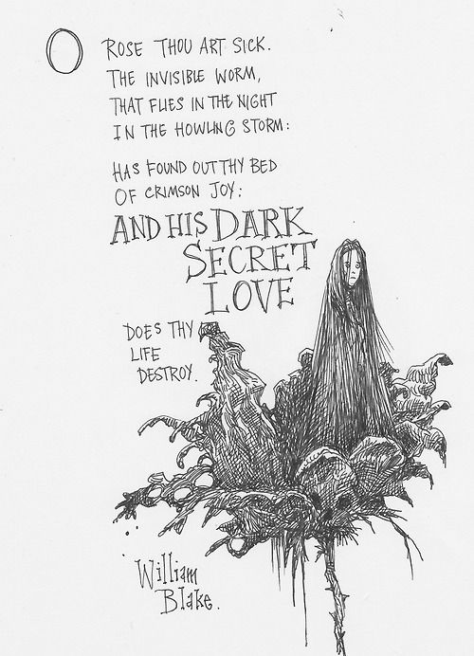
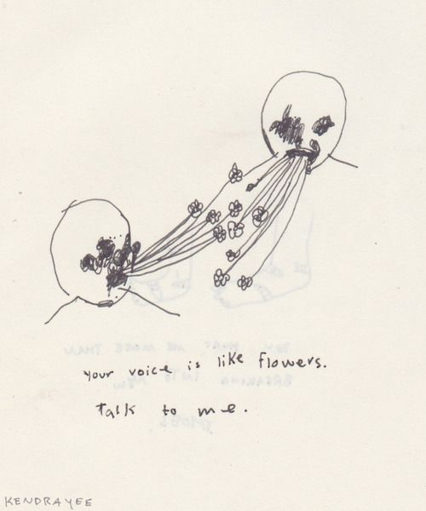
Your life is your life don’t let it be clubbed into dank submission. be on the watch. there are ways out. there is light somewhere. it may not be much light but it beats the darkness. be on the watch. the gods will offer you chances. know them. take them. you can’t beat death but you can eat death in life, sometimes. and the more often you learn to do it, the more light there will be. your life is your life. know it while you have it. you are marvelous the gods wait to delight in you. 4. “The Water Crisis” by Sanjeev Kumar The summers are back, the hotness is back, Expect the wake of the atmosphere harsh, To see the geography that abounds in nature, But the heat makes up; here is no water, only hope, That the rain would fall and make the earth alive, There is rock, stones, and the roads that are dust-laden, Those are alive for now, the travel through them winds, Among the curvaceous mountains, yes! So curved, that you almost lurch off into the dike, Every now and then, rocky spaces, structures without, Water; should the animals, the birds and the humans not, Stop and drink if there were some, but the rocks are dry, The sands are dry, the channels are dry, and the sky is dry. Only thing that is wet is our own self, but even the sweat, Threatens to go dry leaving the skin dry like the land, That is parched with the heat that robbed the land of, The last drop of water, one cannot stop or think, For the feet are either in the sand or in the air, To save the very last and precious drop of life, Only if there were water amongst the lands, the rocks, The land would not have been susceptible to carrions, There would have been no silence in the mountains, With the noise of the flow of the stream, that would, Have turned the sterile ground breeding fertile, alas! There is not even loneliness in the places dried, the people, Their reddish morose faces peeking from the mud thatches; Only if there were water, plenty of those and no sand, no dust, But more water, spring, and pools among the mountains, the rocks, And the sound of the rain-bearing clouds to make the nature happy.
